**Lab File**

Exploring the Networks



Amity School of Engineering & Technology

Amity University

Noida, Uttar Pradesh

**By-**

Kuldeep Dwivedi

A2305218477

5CSE-7Y

**Experiment 1**

**Basic Command Prompt Commands**

Network Commands used in Command Prompt:

1. **ipconfig:** This command is used to check the IP configuration of the system.

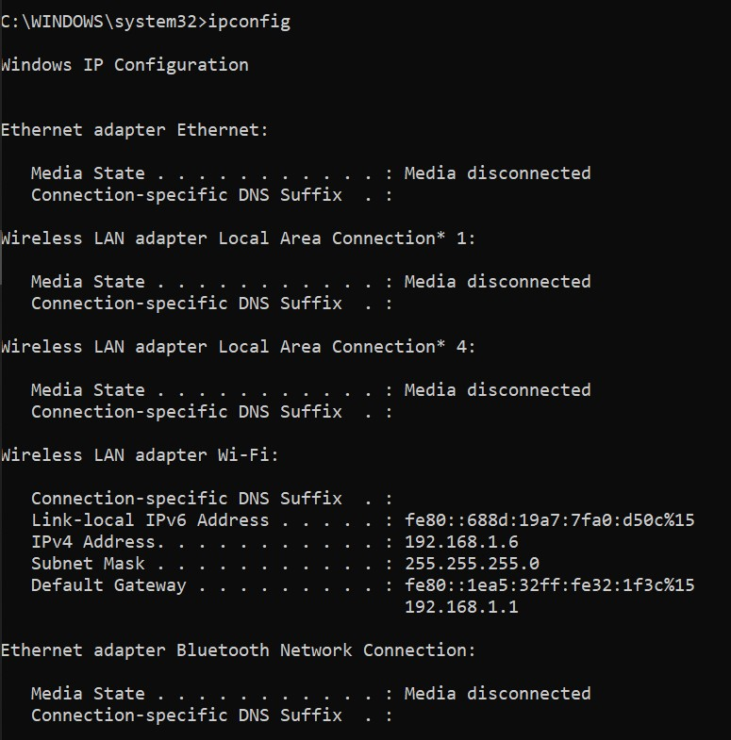

b.) **hostname:** Used to show or set a computer’s hostname and domain name.

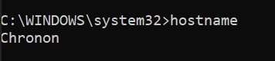

c.) **netstat 192.168.1.5:** Displays network connection, routing tables, and a number of network interface statistics. Used for finding problems in network.

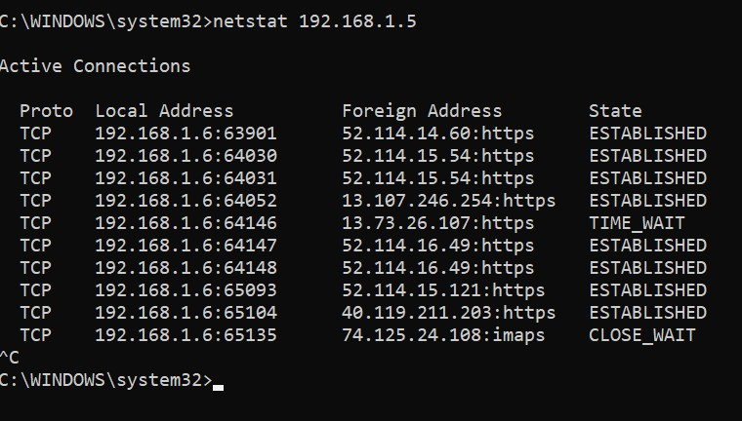

d.) **ping 192.168.1.5:** This command is used to test the connection and latency between two network connections.

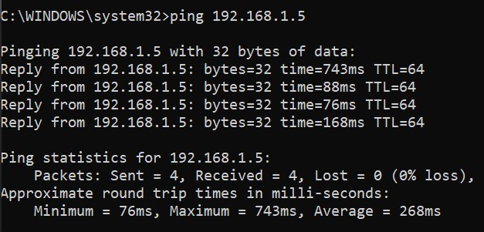

e.) **pathping 192.168.1.5:** Combines the functionality of ping with that of traceroute, by providing the details of the path between two hosts.

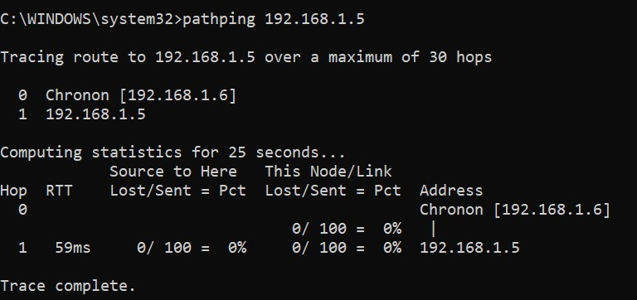

f.) **tracert 192.168.1.5:** It is a network tool used to determine the path packets take from one IP address to another.

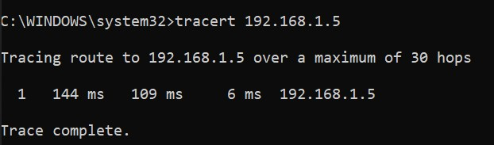

**g.) arp -a:** used to perform IP address resolution which is the linking of IP address to MAC address.

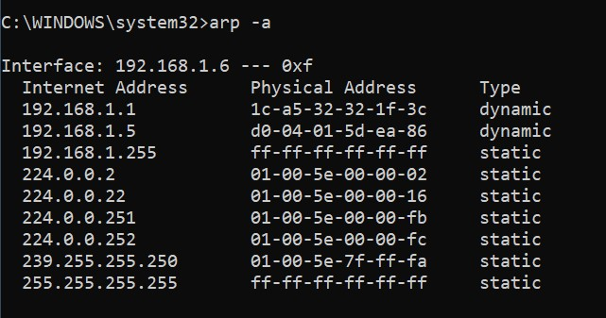

h.) **arp -n count**

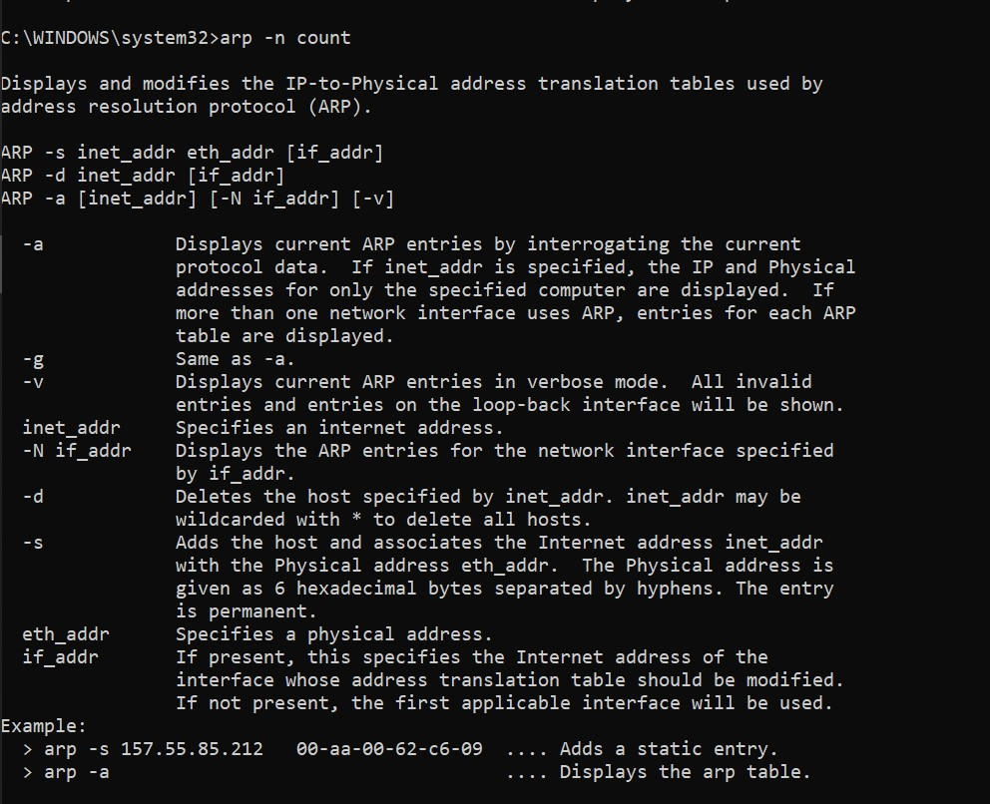

**Experiment 2**

**Topologies**

**Network Topology** is the schematic description of a network arrangement, connecting various nodes(sender and receiver) through lines of connection.

**Different Topologies:**

1. **Point to Point Topology: Point to Point topology** is the simplest topology that connects two nodes directly together with a common link. The entire bandwidth of the common link is reserved for transmission between those two nodes. The point-to-point connections use an actual length of wire or cable to connect the two ends, but other options, such as satellite links, or microwaves are also possible. When you change TV channels by remote, you are establishing a point-to-point connection between the remote control and the TV’s control system.

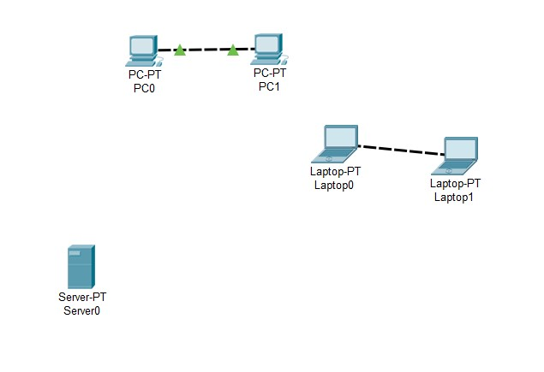

**Figure Point to Point Topology**

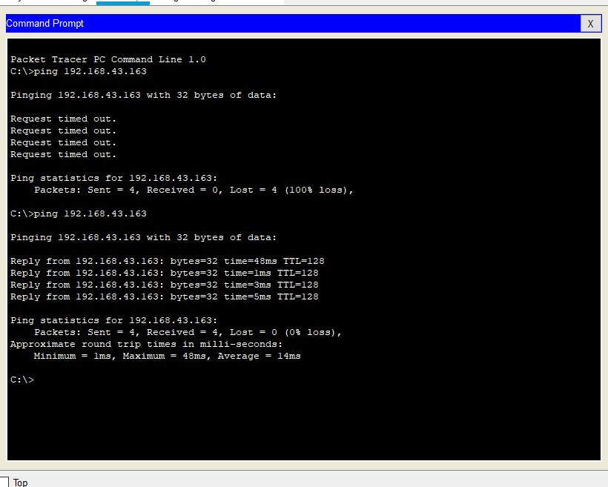

**Figure Command Prompt for Point-to-Point Network**

1. **Star Topology:** In **Start Topology,** all the computers are connected to the central located device called as hub. All the devices on the network are connected with a hub device through a communication link. Each computer requires a single wire for the connection to the hub.

If one host needs to send data to some other host, it will send the message to the central connecting hub device. The central connecting hub device then replicates the message and forwards it on to the appropriate host.

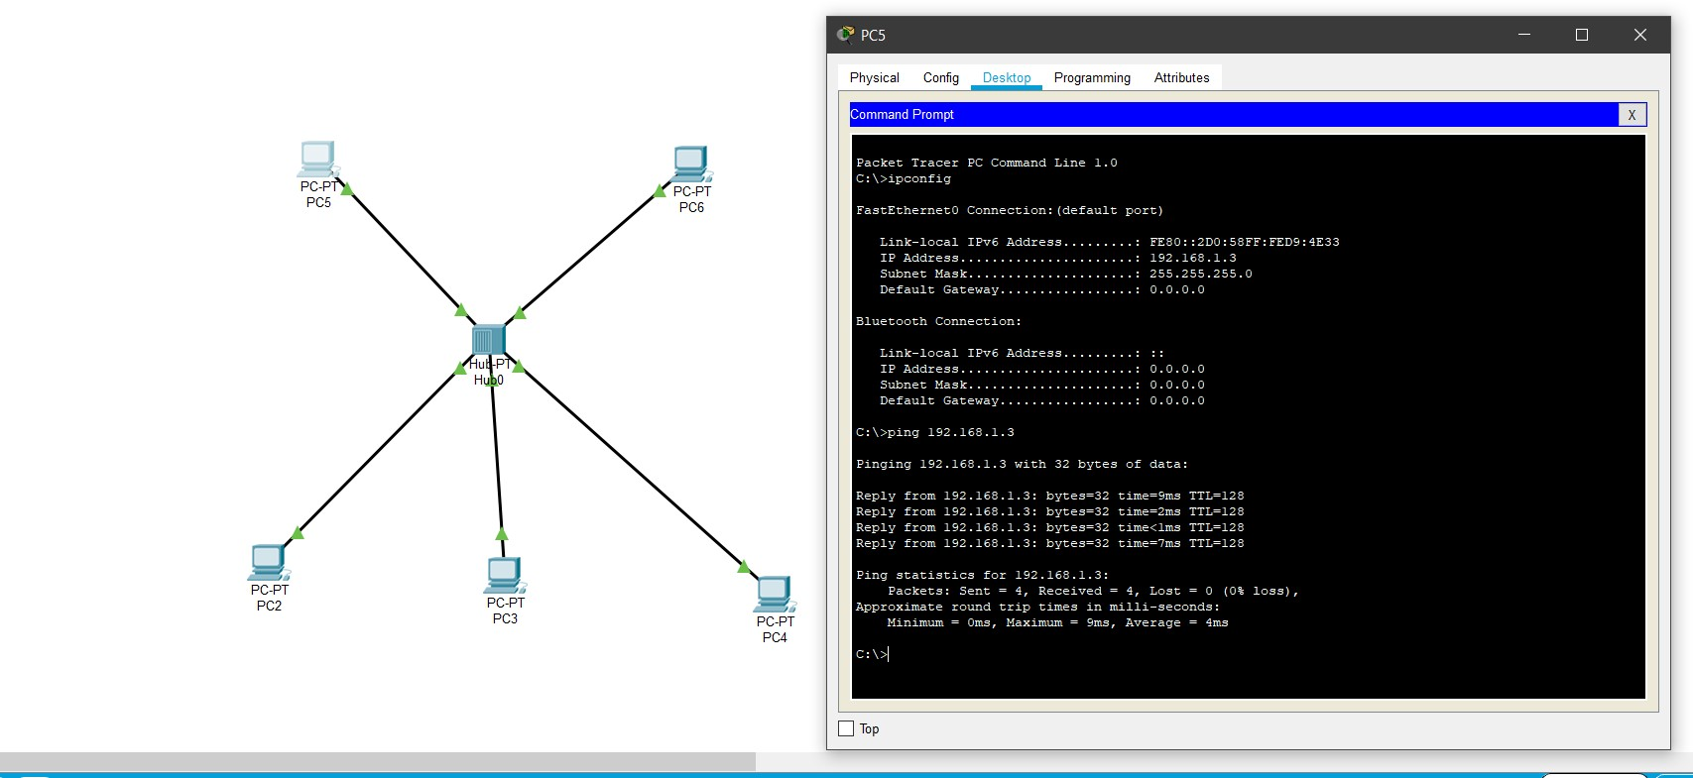

**Star Topology**

1. **Ring Topology:** In **Ring Topology**, each device/node is connected with its neighbouring node forming the shape of ring hence it is known as Ring Topology. In ring topology the data circulate from one computer to another.  The flow of the data in ring topology can be uni-directional or bi-directional.

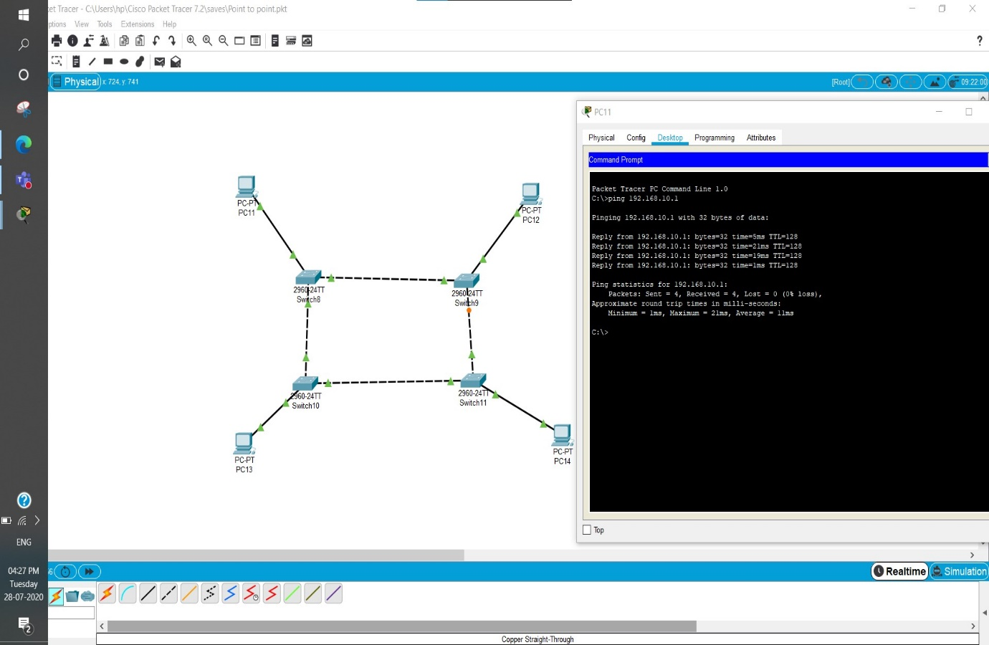

**Ring Topology**

1. **Mesh Topology:** In **mesh topology,** all the computers are inter-connected to each other in a network. Each computer not only sends its own signals but also relays data from other computers. This type of topology is very expensive as Its very difficult to establish the connections of the mesh topology. In a Mesh topology every node has a point-to-point connection to the other node. The connections in the mesh topology can be wired or wireless.

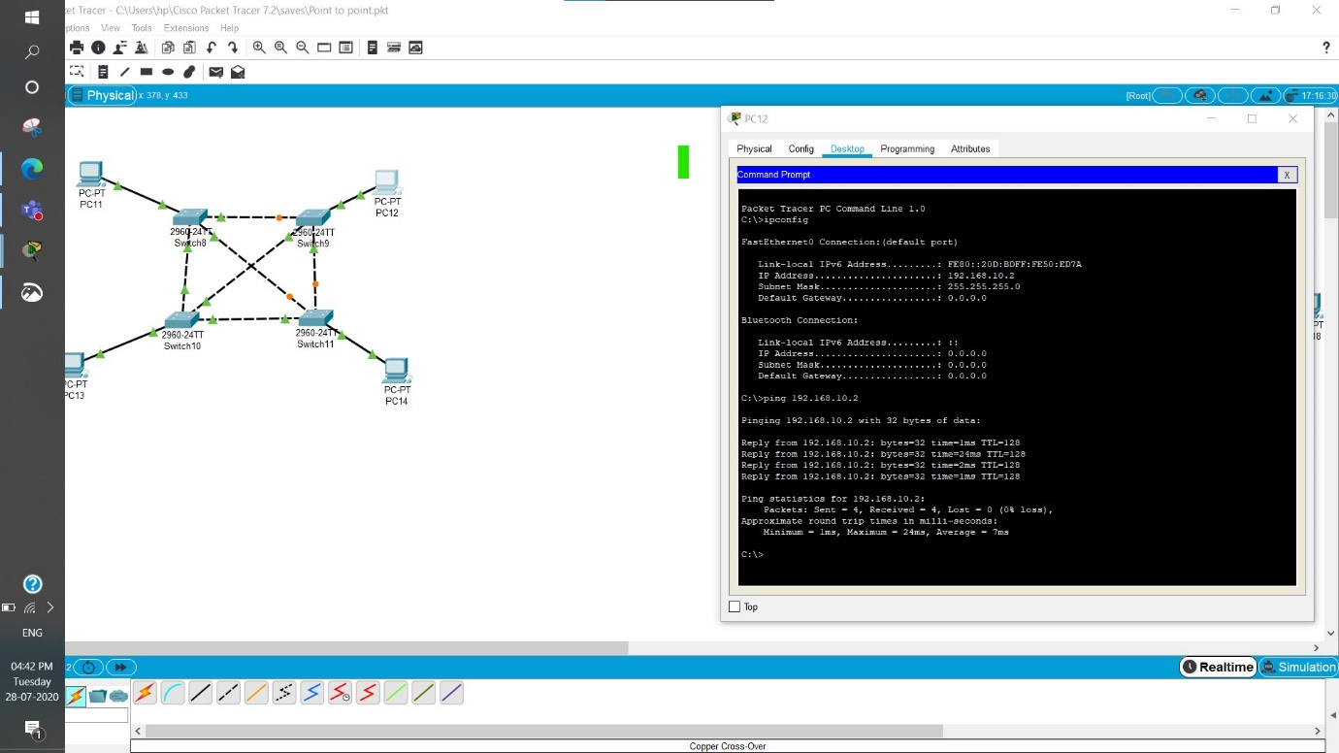

**Mesh Topology**

1. **Bus Topology:** A **bus topology** consists of a single cable with the terminator at each end. All present nodes are connected to the single cable. There is no limit to the no: of nodes that can be attached to this network, but the no: of connected nodes can actually affect the performance of the network.

In a bus topology, one of the nodes acts as the server and transmits the data from one end to the other in a single direction. When the data reaches the extreme end, the terminator removes the data from the line.

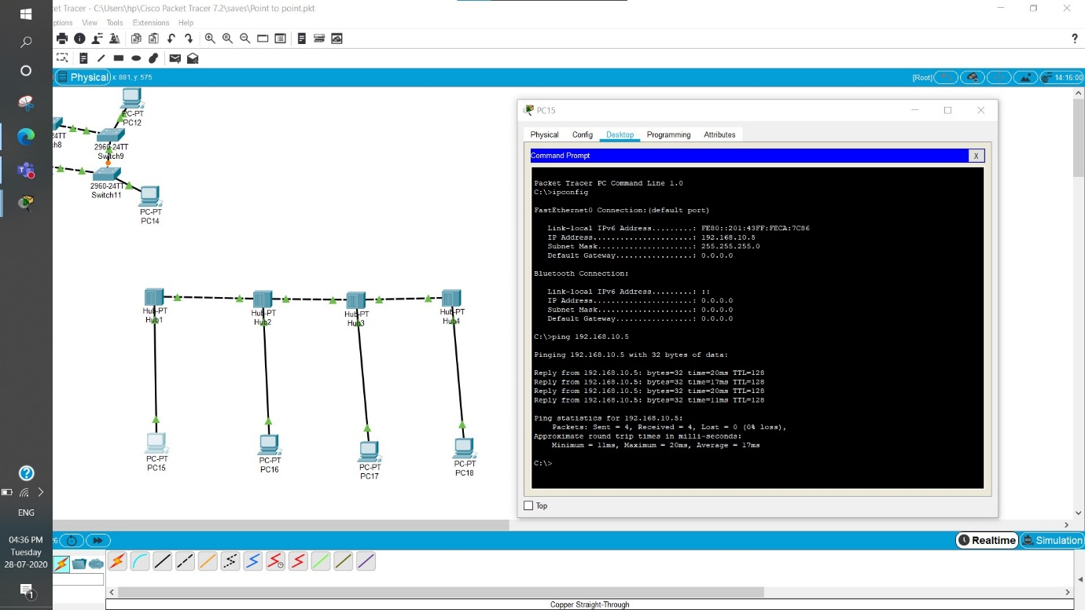

**Bus Topology**

**Experiment 3**

**Hub vs Switch**

**What are networking devices?**

Hardware devices that are used to connect computers, printers, fax machines and other electronic devices to a network are called **network devices**. These devices transfer data in a fast, secure and correct way over same or different networks. Network devices may be inter-network or intra-network. Some devices are installed on the device, like NIC card or RJ45 connector, whereas some are part of the network, like router, switch, etc.

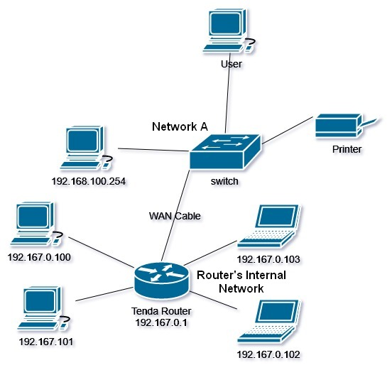

**What is Hub?**

A hub is basically a multiport repeater. A hub connects multiple wires coming from different branches, for example, the connector in star topology which connects different stations. Hubs cannot filter data, so data packets are sent to all connected devices.  In other words, collision domain, of all hosts connected through Hub remains one.  Also, they do not have intelligence to find out best path for data packets which leads to inefficiencies and wastage. That is why, a hub is also considered as least intelligent of all network devices.

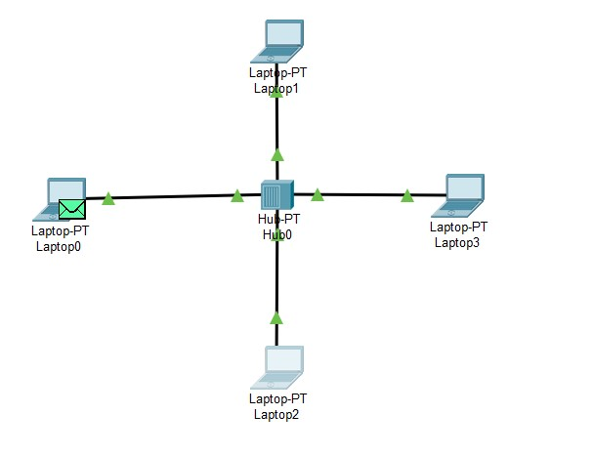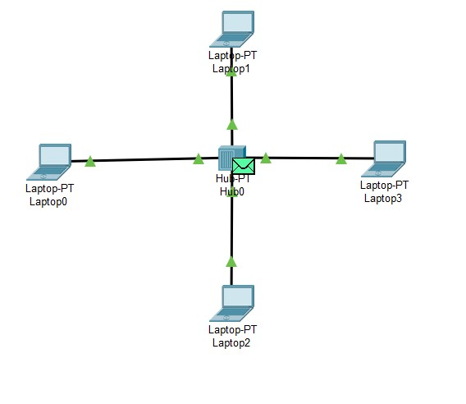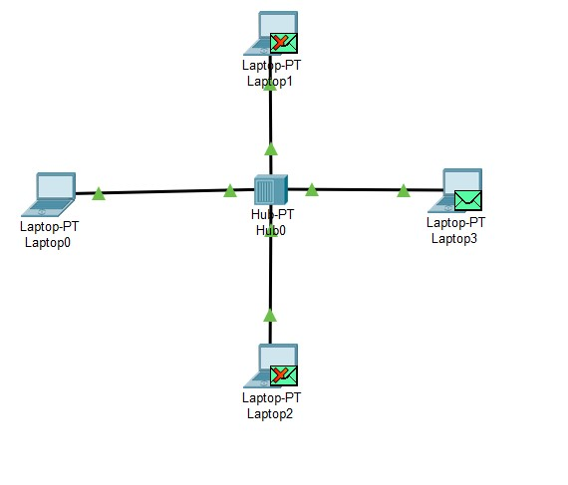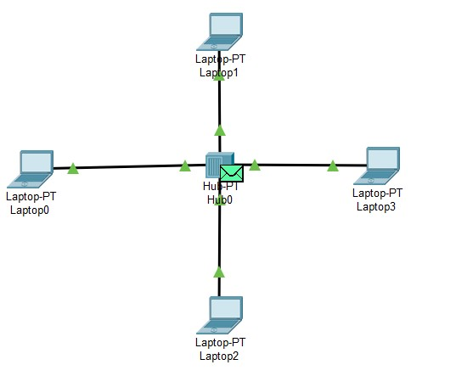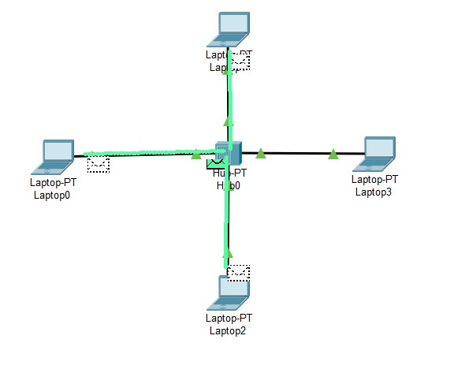

These figures show how hub helps in transfer of data from one device to another. But as it can be seen that hub transmits the data to all the devices connected in a network. Thus, it is not an intelligent device.

**What is switch?**

Switches facilitate the sharing of resources by connecting together all the devices, including computers, printers, and servers, in a small business network. Thanks to the switch, these connected devices can share information and talk to each other, regardless of where they are in a building or on a campus. Building a small business network is not possible without switches to tie devices together. Switch is more intelligent device than hub. It can broadcast, multicast and unicast the data as per the requirements of users.

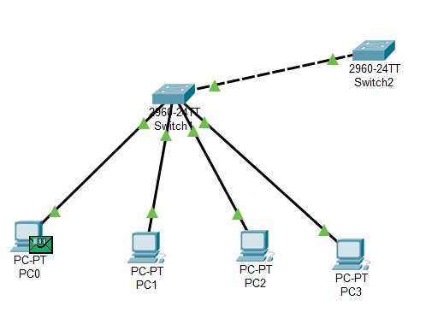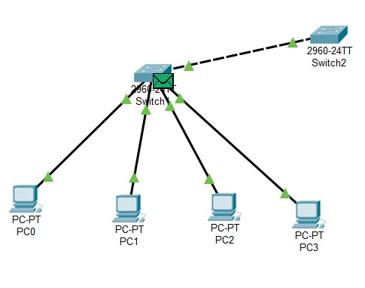

Above figures represent the process of sending data packet from PC0 to PC3. When packet is being send from PC0 to PC3, the data will be first transferred to the switch and switch will forward it to the destination address which is PC3 in this case. Once the packet is delivered to the destination, an acknowledgement message is transmitted back to the source. If source receives this message or data, it means that data has been transmitted successfully else it shows there is some sort of error in the transmission line or the transmission route.

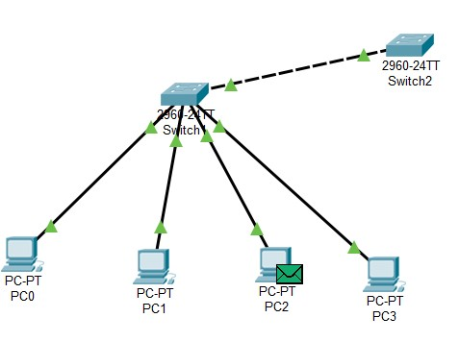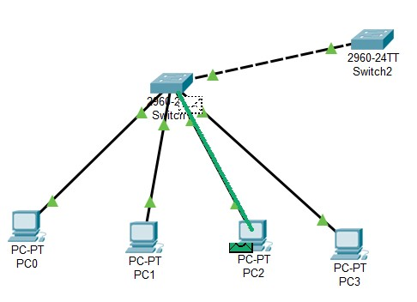

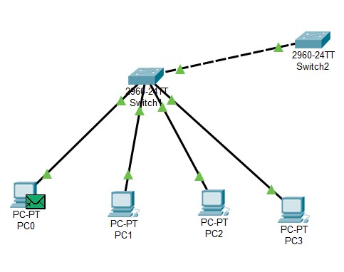

**Experiment 4**

**Topology**

**Objective:**

Create a network topology for university having 5 departments CSE, ECE, ME, CE, EEE. Each having 5 computers. There should be no communication between inter departments. Cost should me minimum for the network infrastructure.

**Theory:**

Hub, switch and routers are used as intermediary network devices to connect end devices. Each network device has its own advantages and disadvantages. In the given situation, we need a device which is capable of handling this much number of devices and it should make sure that there is no inter-department communication.

We have already studied about the networking devices. Hub is economical but it will allow the inter-department connection or communication. Switch is the device which fulfils all the above conditions hence we will use a switch.

**Setup:**

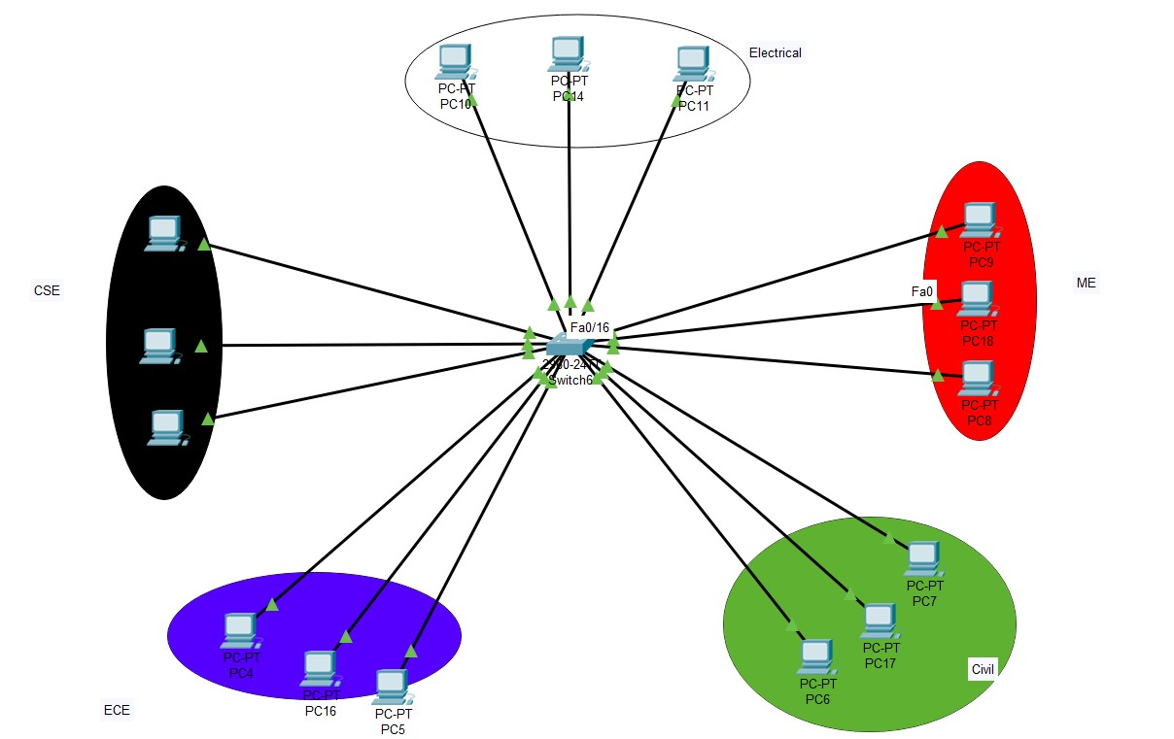

**Network topology for 5 departments in a university**

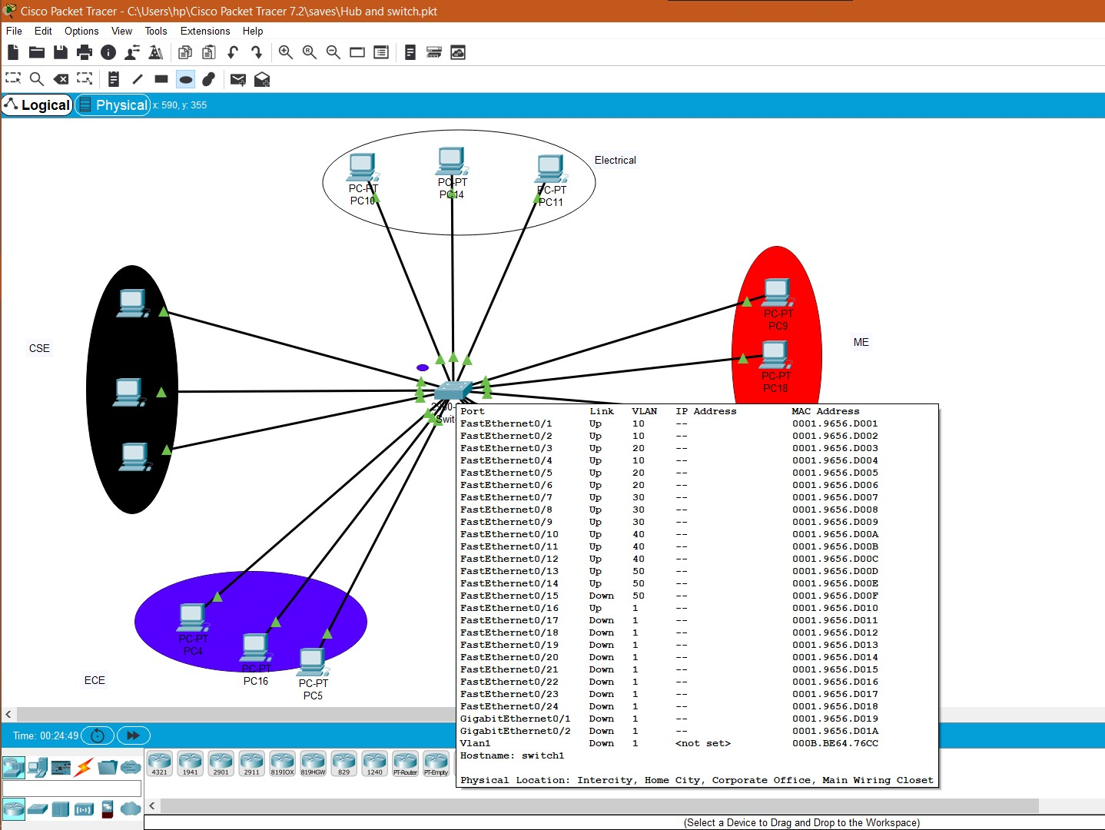

**Status of switch showing the configuration**

**Experiment 5**

**Router**

**Objective:**

Understanding the working of a router and connecting two topologies using a router.

**What is Router?**

The router is a physical or virtual internetworking device that is designed to receive, analyse, and forward data packets between computer networks. A router examines a destination IP address of a given data packet, and it uses the headers and forwarding tables to decide the best way to transfer the packets.

A router is more capable as compared to other network devices, such as a hub, switch, etc., as these devices are only able to execute the basic functions of the network. For example, a hub is a basic networking device that is mainly used to forward the data between connected devices, but it cannot analyse or change anything with the transferring data. On the other hand, the router has the capability to analyse and modify the data while transferring it over a network, and it can send it to another network. For example, generally, routers allow sharing a single network connection between multiple devices.

**Setup:**

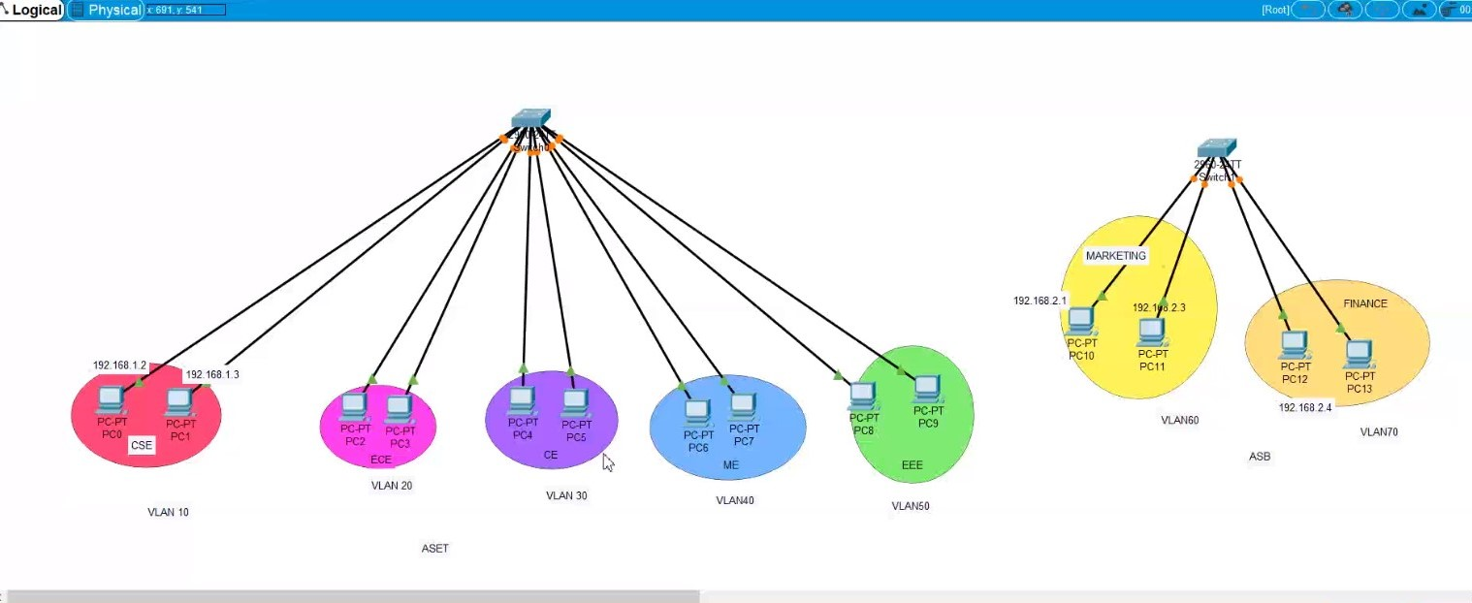

**Two topologies which are not interconnected**

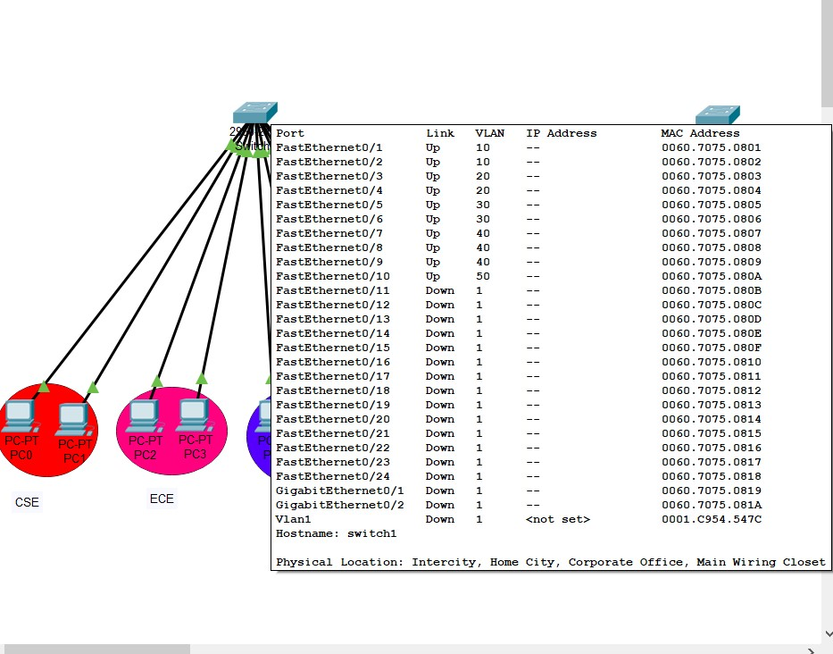

**Configuring the switches and assigning IP address to end devices**

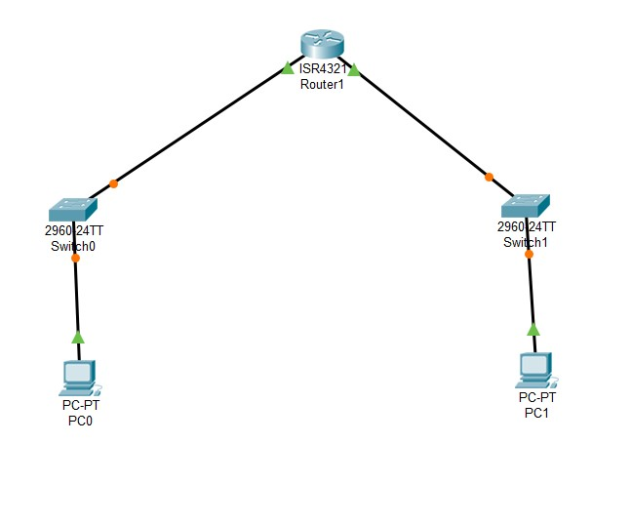

**A simple network interconnected using router**

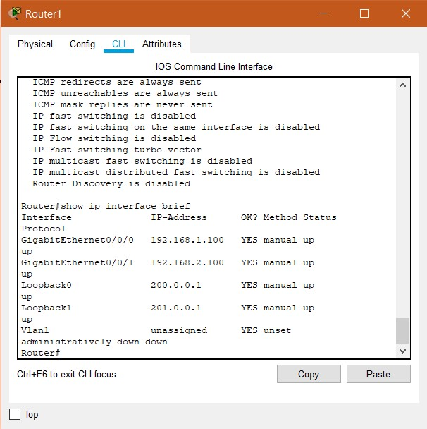

**Configuring the router**

**Experiment 6**

**Connecting two networks using switch**

**Objective:**

Construct two topologies and connecting them using two switch and configuring the switches to enable the inter-network or inter-topology communication.

**What is Switch?**

Switches facilitate the sharing of resources by connecting together all the devices, including computers, printers, and servers, in a small business network. Thanks to the switch, these connected devices can share information and talk to each other, regardless of where they are in a building or on a campus. Building a small business network is not possible without switches to tie devices together. Switch is more intelligent device than hub. It can broadcast, multicast and unicast the data as per the requirements of users.

**Setup:**

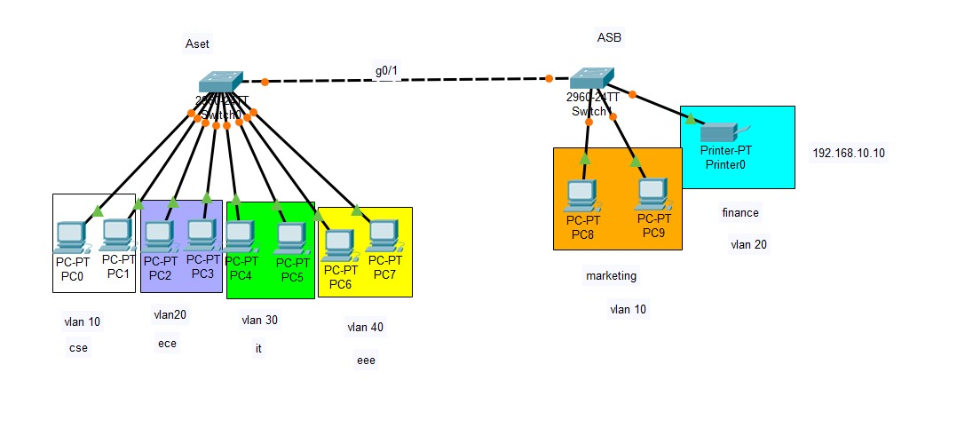

**Connecting two networks using switch**

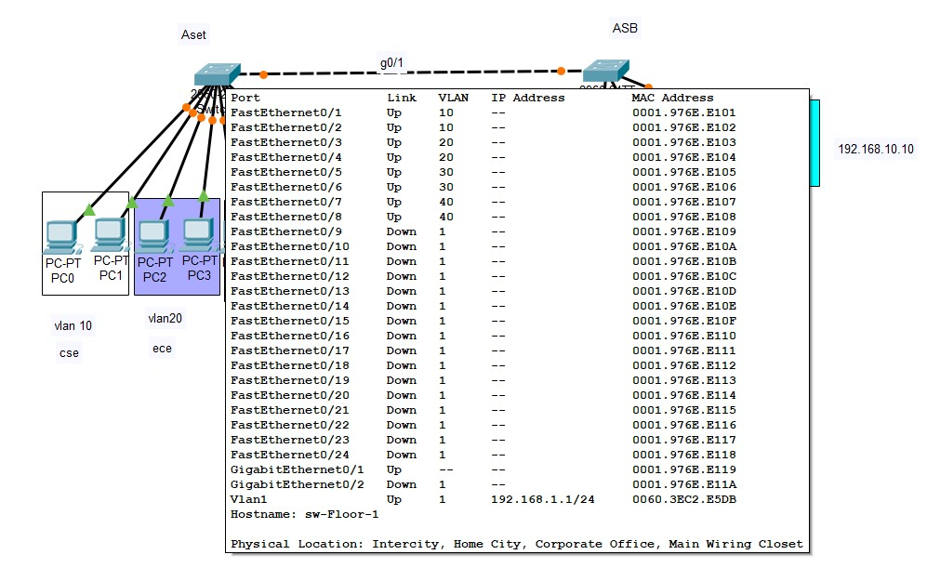

**Configuration of Switch 0 in network**

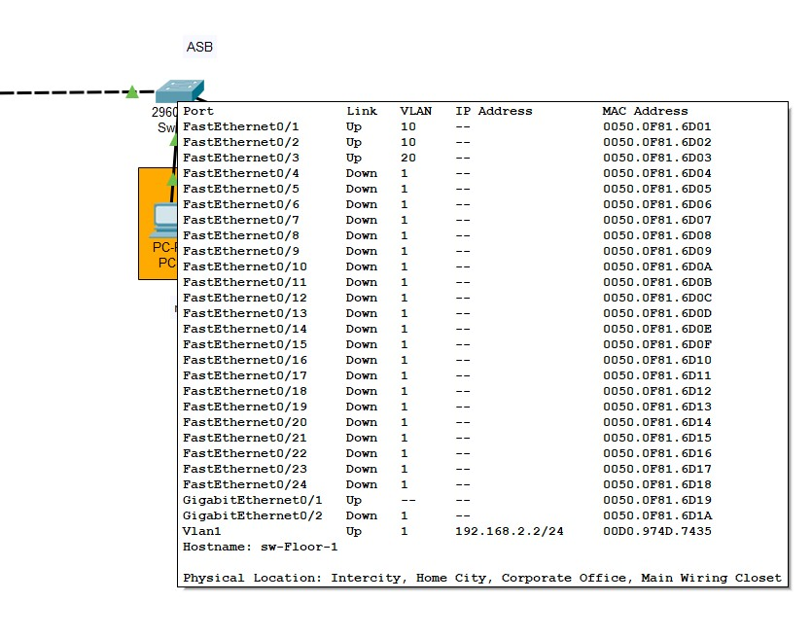

**Configuration of Switch 1 in network**

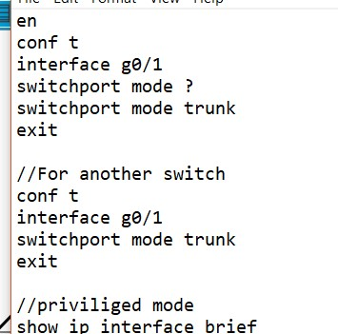

**Commands for switchport trunk mode (Configuring gigabit connection)**